***THE EL FANAR***

El Fanar Beach is a picturesque and popular beach located in Sharm El Sheikh, Egypt, along the Red Sea coast. Here are some key details about El Fanar Beach:

1. 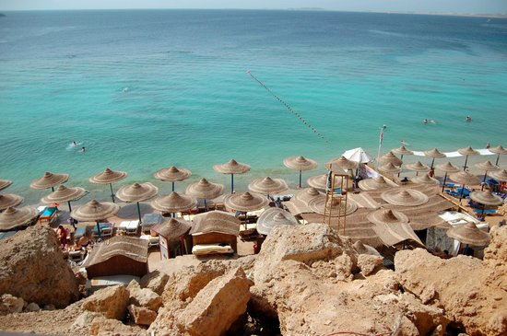**Location**: El Fanar Beach is situated in Sharm El Sheikh, which is a renowned resort town on the southern tip of the Sinai Peninsula in Egypt. It lies along the coast of the Red Sea, known for its exceptional diving and snorkeling opportunities.

The beach is celebrated for its stunning views of the Red Sea and the surrounding desert landscape. The crystal-clear waters and vibrant marine life make it a haven for underwater enthusiasts.

El Fanar Beach is particularly famous among snorkelers and divers due to its proximity to vibrant coral reefs teeming with colorful fish and other marine creatures. Snorkeling and scuba diving trips are popular activities here, allowing visitors to explore the rich underwater world.